# Networking Lab 3 Routers

## IP Addresses

The biggest question a computer must answer about an IP address is: “Is the address I want to talk to on my network (use ARP and talk directly) or is it on another network (use default gateway)?”

Together, the IP address and subnet mask let you answer that question. In binary, the subnet mask will be all ‘1’s in the network portion, and ‘0’s in the host portion. The easiest mask is 255.255.255.0

255.255.255.0  
11111111.11111111.11111111.00000000

For the IP address 192.168.15.162, that breaks down to this:

|  |  |  |  |
| --- | --- | --- | --- |
| 192. | 168. | 15. | 162 |
| 11111111. | 11111111. | 11111111. | 00000000 |

The network portion of 192.168.15.162 is 192.168.15.0. Any address that starts with 192.168.15 is on the same network, and anything else is on a different network. Note that there are 256 (0 - 255) possibilities for the host portion of the address; in the example above the host portion is 162. There are two reserved numbers, however. The lowest possible host number (0 in this case) is reserved for the network itself, so the network above is 192.168.15.0. The highest possible host number (255 in this case) is reserved for the network broadcast address, so 192.168.15.255 would be sent to all hosts on the 192.168.15.0 network.

For this lab, we will use a 255.255.255.0 subnet mask, and network addresses starting with 192.168.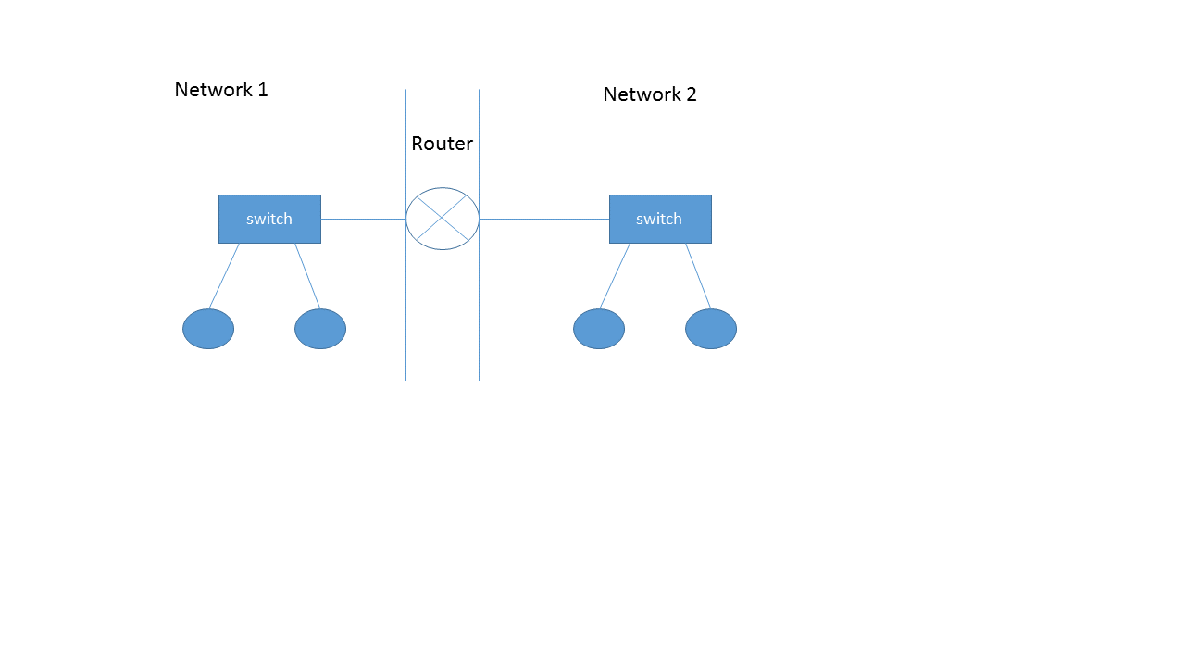

Subnet address: __________________________ Subnet address: _________________________

Subnet mask: ___________________________ Subnet mask:___________________________

Router Address: _________________________ Router Address: _________________________

Host 1:_________________________________ Host 3:_________________________________

Host 2: _________________________________ Host 4: _________________________________

Work together as a group so that you agree on the IP networks and addresses you will use.

1. Select two network addresses with subnet masks and put them in the form above.
2. Select the two router interface addresses you will use and put them in the form. Remember that the lowest address (often 0) is reserved for the network itself and the highest address (often 255) is reserved for the broadcast address. Often, the router address is chosen to be 1, but there is no requirement to do that.
3. Select addresses for your four hosts (computers) and put them in the form.

## Simulate the Network

Use Packet Tracer to create a simulation of your network. The router should be a 2911, as it is closest to the hardware we will use. Use 2960 switches.

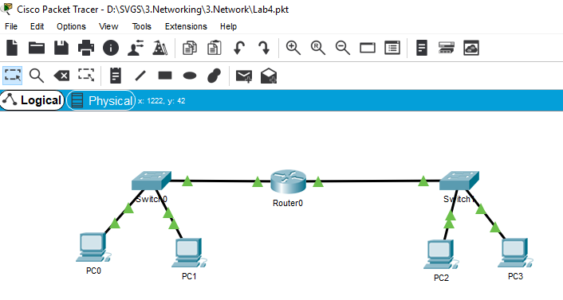

1. In the router, configure the two addresses you selected on the interfaces you connected to the switches. Be sure to turn the interfaces on.  
   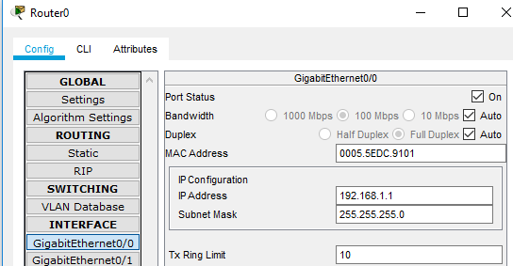
2. We don’t need to configure anything on the switches for this lab
3. For the four PCs, configure the IP address and subnet masks you selected. The IP addresses should all be different, and on the correct networks. For the default gateway, use the address of the router interface that is on the same switch as the PC.

For this simple lab, the only networks that exist are connected to the router. Later, we will use more complicated networks and will have to tell the router how to reach networks that are not directly connected.

1. Open the router CLI and enter, show ip route. This will show you the router’s table of routes. You should see that the router is directly connected to the two networks you configured.
2. Test to see that the PCs can ping the router interfaces, and each other. Correct any problems you encounter.

## Build the network in hardware

Use the classroom computers, lab switches and lab routers to configure your network in hardware.

1. Configure your lab with the same connections and addresses you simulated.
2. Test to see that you can ping the other host on your subnet and a host on the other side of the router. Troubleshoot as needed.
3. Record the MAC addresses for your hosts, and for the default gateways (the two router interfaces.) If you ping the router, you should be able to find its MAC address by examining the arp cache on your host (Linux: the command is arp; Windows: the command is arp -a)

## Routers rewrite the layer 2 portion of the packet

In this portion of the lab you will verify that routers rewrite the layer 2 portion of packets by changing the source and destination MAC addresses. Switches do not change the layer 2 addresses.

### Hosts on the same network (same switch in this lab)

Compare Wireshark packet captures on traffic between hosts on the same network. We will send a netcat or ncat message (or just a ping) to the other host that is connected to your switch. It should be on the same network as your host. First, though, start a Wireshark packet capture on both hosts.

* 1. What MAC addresses appear in the packets (ie, what hosts do they belong to?)
  2. Look at the entries in your arp cache. Is the entry of the other host in the cache?
  3. Compare the source and destination MAC addresses in the Wireshark captures from each host. How are they related?
  4. Compare the source and destination IP addresses in the Wireshark captures from each host. How are they related?

### Hosts on different subnet

Repeat the steps you just did, except when hosts on different networks are communicating. Send the message or ping to a host on the other side of the router and compare the results when you take Wireshark packet captures on the two hosts.

1. What MAC addresses appear in the packets (ie, what hosts do they belong to?)
2. Look at the entries in your arp cache. Is the entry of the other host in the cache?
3. Compare the source and destination MAC addresses in the Wireshark captures from each host. Are they related?
4. Compare the source and destination IP addresses in the Wireshark captures from each host. How are they related?
5. Compare the MAC addresses with the MAC addresses on the router.

How do your answers compare to what you had between hosts on the same network?

## Hand in

1. When two hosts are on the same network, does the MAC address in the packet change as it goes from one host to the other?
2. When two hosts are on the same network, does the IP address in the packet change as it goes from one host to the other?
3. When two hosts are on different networks, does the MAC address in the packet change as it goes from one host to the other?
4. When two hosts are on different networks, does the IP address in the packet change as it goes from one host to the other?
5. Do these answers match what you saw when you compared Wireshark packet captures?